Battery internal resistance influence on voltage-based balancing algorithms

M. SOCA**[1]**

**Abstract:** *Evolving technologies such as smart grids and EVs require their batteries to be operated safely and cost-effective and a battery management system is always used to achieve that. This project focuses on building a battery management system that can passively balance four cells connected in series of a battery pack. The appropriate technology to build the system was selected and the circuit and software were developed. Two voltage-based algorithms for passive balancing were tested and results compared.*

**Key words:***SoC approximation, passive balancing, internal resistance of cell battery*

# Introduction

Batteries premature failure can be caused by not making use of their full capacity. Variations in the physical volume, internal impedance and different self-discharge rates of the cells are a cause [1]. Then, as not all the cells are identical, they will charge and discharge at different rates and the charging/discharging process will stop as soon as the first one reached or finished its full capacity.

To prolong the cell’s life, their state of charge can be balanced during a charge or discharge process. The methods available are passive and active balancing [2].

Passive balancing dissipates the energy from the strongest cells discharging them through a resistor, until the weakest ones reach their full capacity. The same principle is applied by active balancing, only that the energy is not wasted but transferred from the strongest to the weakest cell.

The main approaches identified were bottom, mid and top balancing. Mid-balancing and top balancing techniques are the most widely used because they are used for EVs applications that require the battery to be kept at 50% SoC (state of charge) or because they allow the battery to store more energy.

The state of charge of a battery describes the available capacity as a percentage of its rated one. In [2], the SoC variations of a car battery’s cells are evaluated with and without cell balancing. The method used is mid-balancing as the cells are balanced at 50% SoC.

Balancing algorithms are based on SoC calculation. This can be achieved by voltage translation and/or coulomb counting. The voltage-based algorithm has two main limitations. First, it assumes that the cells of different voltages are of different SOC, when the terminal voltage of a battery is not the same as the OCV (open circuit voltage), as there is a voltage drop across its internal resistance. Second, the voltage vs. time is quite flat for Lithium batteries [3].

Moreover, the OCV may not be the best indicator of the SOC, as it takes time to reach a steady-state. After the charging or discharging process is stopped, the terminal voltage of the cell (OCV) takes time to reach the relaxation voltage, often associated with the EMF (electromotive-force) [4]. In their application notes for cell balancing ASICs (application specific integrated circuit), Texas Instruments also state that terminal-voltage-based balancing may not be accurate, due to the *IR* contribution of the internal resistance of the cells while charging/discharging. The relaxed voltage after charging (the true OCV) shows imbalances between the cells. Figure 1 is used to illustrate this [5].

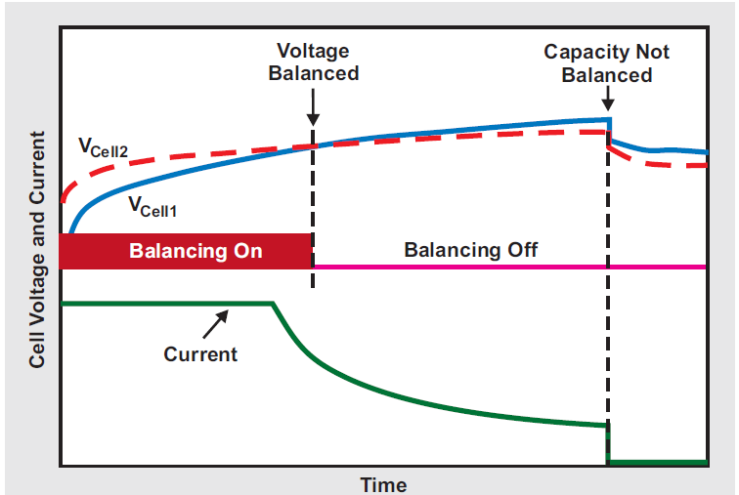

*Fig. 1. Terminal voltage-based balancing [5]*

Some studies have discussed the problem associated with deriving the SoC from the terminal voltage. For example, David Andrea in his book [3], shows how the terminal voltage curve vs. the SoC is different for various discharge and charge rates as the current variation leads to a variation in the IR drop. However, knowing the current and the resistance for each cell, the OCV can be calculated. [6] also tried to approximate the SoC directly from the terminal voltage for a Lead Acid battery and have concluded that for different currents, the parameters for the approximation curve were different. Then, it proposes two equations to model the SoC as a function of both the terminal voltage and the internal resistance of the battery, as both vary with the SoC and the error for both were compared. Other methods for deducing SoC from the OCV are [7-9] or [10-11] and they require a long time for the voltage to relax to its open circuit value. To reduce the relaxation time, some efforts were made by building an OCV relaxation model [12]. New methods developed make use of neural networks [13-15] and adaptive Kalman filters [16-17], that deal with sensor noise and observation nonlinearity. In [18], the SoC is estimated with the use of an extended Kalman filter and the real time internal resistance value, which can adapt to internal ageing and external temperature. In [19], the OCV is calculated using the ECM (equivalent circuit model) of the battery and is expressed as space states and the SoC is also estimated using a state observer and it is concluded that the internal resistance is the parameter with the most influence on the estimation. Another simpler method, [20], estimates the SoC of a battery by stopping the charge to compute the internal resistance of the battery and then further use the value while charging, to compute the actual OCV and derive the SoC from it. A similar method will be used in this study, to compute the OCV. However, all the studies mentioned above do not assess the performance of the SoC estimations for a balancing system. This study aims to confirm the importance of the internal resistance for the SoC estimation, comparing two balancing algorithms: one inferring the SoC of the cell from the terminal voltage only, and one using the derived OCV (calculated with the use of the known current and internal resistance).

# Objectives

The aim of this project was to build a battery management system based on an ASIC design, to balance 4 cells connected in series, when out of balance. The algorithm is distributed between 2 systems, communicating with each other:

An Arduino system to communicate with the ASIC via SPI (Serial Peripheral Interface) commands, to set and acquire parameters for balancing and an Atmega128 system used to run the control loop, with the use of an operating system (FreeRTOS). The system aims to demonstrate a passive balancing technique based on events (ex: a cell is more charged than the others). The communication between the Arduino and Atmega128 board is to be done via I2C (Inter Integrated Circuit). The system was used to prove the passive balancing concept and to evaluate its performance in two case scenarios: one where the SoC of the cells is directly derived from the terminal voltage of them and the other, where the internal resistance of the cells is taken into account to derive the actual OCVs of the cells.

Objectives:

- Review the balancing techniques available

- Select technology to implement a passive balancer

- Build the circuit to balance four cells in series

- Build a program to run a balancing algorithm, making use of the FreeRTOS operating system

- Derive the cells’ internal resistance

- Perform balancing test based on terminal voltage measurement

- Perform balancing test based on OCV derived from knowing the internal resistance of cells

- Compare the performance of the two tests

# Material and Methods

* 1. **System overview**

The best considered approach for the system is a design based on an application specific IC for battery management [3]. The IC incorporates most of the key functions of a battery management system, such as cell voltage measurement (reducing the risk of measurement error) and driving pins for by-passing the cells. The chip was selected for having dedicated pins for driving external MOSFETs, as they can handle more power than internal ones.

The block diagram in Figure 2 summarizes the main components of the system and the way they interact with each other.

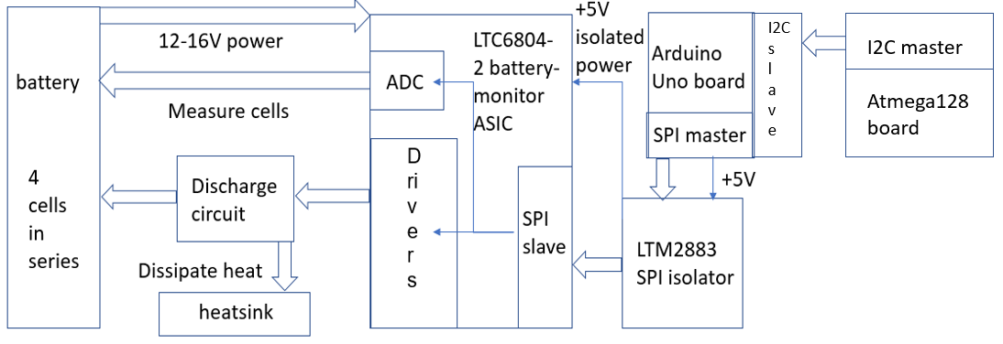

*Fig. 2. System’s block diagram*

The IC performs tasks based on SPI commands that it receives. The main types of commands used are “READ” and “WRITE” commands from/to the IC’s (integrated circuit) registers and “ADCV” commands that perform ADC conversions on the inputs specified in the command.

The balancing algorithm is described in the flowchart in Figure 3. The code written is based on the FreeRTOS operating system and has two main tasks running in parallel: the writing and reading to\from the Arduino Uno slave and the calculation of the discharge pattern. The shared resources between the two tasks are the voltage readings buffer and the computed discharge pattern. Atomic access is given to both with the use of mutexes.

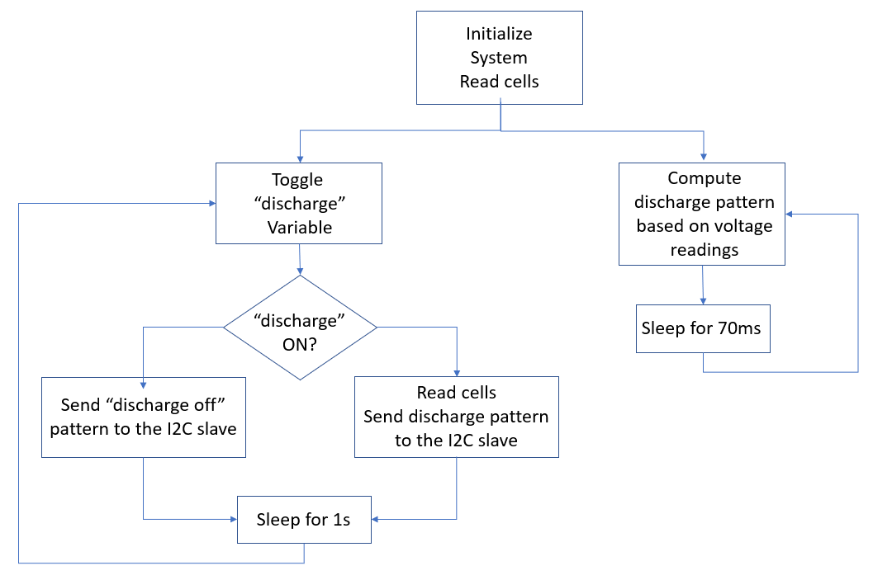

*Fig. 3. Balancing algorithm flow-chart*

## 3.2. Test methods

To prove the importance of the internal resistance for cell balancing, the internal resistances of the cells had to be calculated. To do so, the battery was charged with 4A for one minute and let to rest for two minutes for the voltage to relax to its OCV value. The procedure was repeated 20 times, and the resistances value were calculated by the formula:

$R_{cell}=\frac{V_{terminal}-V_{OCV}}{I}$ (1),

where $R_{cell}$ is the internal resistance of one cell, $V_{terminal}$ is the terminal voltage of the cell, measured while the battery is charging, $V_{OCV}$ is the open circuit voltage measured while the charging is off and $I$ is the charging current, i.e. 4A. The values obtained for each cell were averaged and their values are showed in Table 1.

*Internal resistance estimations* Table 1

|  |  |  |  |
| --- | --- | --- | --- |
| $R_{cell1}$ (µΩ) | $R_{cell2}$ (µΩ) | $R_{cell3}$ (µΩ) | $R_{cell4}$ (µΩ) |
| 84.8 | 83.6 | 86.8 | 89 |

Top balancing tests were performed, starting with similar SoC and OCV respective for both tests, with

$V_{cell2}< V_{cell3}< V_{cell1}<V_{cell4}$ (2),

where $V_{celln}$, is the OCV for cell number n.

For the first test, the discharge pattern was calculated based on the terminal voltage of each cell. For the second test, the discharge pattern was calculated based on the OCV of each cell, calculated with the formula:

$V_{OCV}= V_{terminal}-IR_{cell}$ (3),

where $V_{OCV}$ is the open circuit voltage of a cell, $V_{terminal}$ is the terminal voltage measured across the cell, $I$ is the charging current and $R_{cell}$ is the internal resistance of the cell.

# Results and discussions

The plot in Figure 4 shows the voltage levels of the 4 cells while the battery is charging and top balancing is performed. The control is based on terminal voltage measurements of the cells. It can be seen that at first, the voltage across cell number 2 lags the other voltages, but as balancing is performed, it catches up with the others.

*Fig. 4. Experiment 1: Terminal voltage-based balancing*

However, it can be observed, that when the charging is stopped and the voltages relax to their open circuit value, all the other cells’ voltages, lag the voltage of cell 2, the reference. That is because, their resistance values were higher, and the voltage drop across them was higher too, when the terminal voltage was measured. It can be seen that the voltage for cell 4 lags the most, as it has the largest resistance value.

The plot in Figure 5 shows the voltage levels of the cells while the battery is charging and top balancing is performed again. The control is based on the calculated OCV, considering the estimated values of the internal resistances. It can be seen that at first, the voltage across cell number 2 lags the other voltages, but as balancing is performed, it catches up with the others.

*Fig. 5. Experiment 2: OCV-based balancing*

However, as the charging stops, the open circuit value of the voltages are much closer together, with the voltage of cell 3 lagging the most. This can be due to the error of estimation of its internal resistance.

Table 2 compares the variations in cells’ OCV, relative to the reference cell (cell 2), for both experiments. Relative improvements for the second experiment (OCV based algorithm) were calculated in percentage, relative to the first experiment (terminal voltage based algorithm).

*Imbalances between the cells and the reference cell* Table 2

|  |  |  |  |
| --- | --- | --- | --- |
|  | **Cell 1 (µV)** | **Cell 3 (µV)** | **Cell 4 (µV)** |
| **Experiment 1** | 16 | 58 | 78 |
| **Experiment 2** | 1 | 40 | 9 |
| **Improvement** | 94% | 31% | 88% |

# Conclusions

First experiment proved that the higher the internal resistance of the cell, the higher are the chances of miss-balancing for it. The second experiment proved that internal resistance modelling can influence positively the performance of a balancing algorithm, even with a low accuracy of its estimation. It can also be deduced that for higher charging currents, its influence increases. Improvements in balancing results should be obtained with the equivalent circuit model of the cells and a more accurate estimation of the SoC.

# Acknowledgements

I would like to thank my supervisor, Prof. Andrew Forsyth, for his assistance in outlining sensible objectives for building this system and his guidance to meet them. I would also like to thank Andrew Berry, Wayne Lawson and Alexandru Onea for the technical support and resources used for the project.

# References

|  |  |
| --- | --- |
| [1] | N. S. A. E. Jian Ciao, "Battery Balancing Methods: A Comprehensive Review," in *IEEE Vehicle Power and Propulsion Conference (VPPC)*, Harbin, 2008. |
| [2] | P. S. S.W. Moore, " A review of cell equalization methods for lithium-ion and lithium polymer battery systems,," in *Society of Automotive Engineers, Delphi Automotive Systems*, 2001. |
| [3] | D. Andrea, Battery Management systems for Large Lithium-Ion Battery Packs, 2008, pp. 65-75, 79-81. |
| [4] | H. J. B. e. a. Valer Pop, Battery Management Systems - Accurate state of charge indication for battery powered applications, Philips Research Book Series, 2008, p. 25. |
| [5] | Texas Instruments, "Cell balancing buys extra run time and battery life" *Analog Applications Journal,* 2009. |
| [6] | S. S. a. A. Kawamura, "A new estimation method of state of charge using terminal voltage and internal resistance for lead acid battery," in *Power Conversion Conference*, Osaka, 2002. |
| [7] | R. B. C.C. Christianson, "US Patent". U.S. Patent 3,946,299, 1975. |
| [8] | R. Eby, "US Patent". U.S. Patent 4,180,770 , 1978. |
| [9] | H. Y. I. R. D. K. S. R. E. Peled, "US Patent". Patent 4,725,784, 1984. |
| [10] | M. A. A. M.A.Hannan, "A review of lithium-ion battery state of charge estimation and management system in electric vehicle applications: Challenges and recommendations" *Renewable and Sustainable Energy Reviews,* vol. 78, pp. 834-854, 2017. |
| [11] | R. L. a. C. Z. L. Pei, "Relaxation model of the open-circuit voltage for state-of-charge estimation in lithium-ion batteries," *IET Electrical Systems in Transportation,* vol. 3, no. 4, pp. 112-117, 2013. |
| [12] | S. D. Waag W, "Adaptive estimation of the electromotive force of the lithium-ion battery after current interruption for an accurate state-of-charge and capacity determination" *Applied Energy,* vol. 111, pp. 416-427, 2013. |
| [13] | J. P. F. d.-B. O. Gerard, " Lecture Notes in Computer Science 1327," 1997. |
| [14] | D. G. S. Grewal, "113-122," in *IEEE International Conference on Telecommunications*, 2001. |
| [15] | L. W. L. C. M. Q. Yang F, "State-of-charge estimation of lithium-ion batteries based on gated recurrent neural network," *Energy,* vol. 115, pp. 66-75, 2019. |
| [16] | G. Plett, *Journal of Power Sources,* vol. 134, pp. 277-292, 2004. |
| [17] | O. N. B. C. J. Lee, "MOSFET as a switch," *Journal of Power Sources ,* vol. 174, pp. 9-15, 2007. |
| [18] | Y. B. J. S. Dian Wang, "Online Lithium-Ion Battery Internal Resistance," *Energies,* 2017. |
| [19] | G. L. F. Y. Li Sun, "Combined internal resistance and state-of-charge estimation of lithium-ion," *Renewable and Sustainable Energy Reviews,* 2020. |
| [20] | J. L. T. J. K. C. B. A. M. A. Patterson, "Apparatus of SOC estimation during plug-in charge mode". U.S. Patent US9354277B2, 31 May 2016. |
|  |  |

1. Faculty of Electrical Engineering and Computer Science, *Transilvania* University of Braşov.